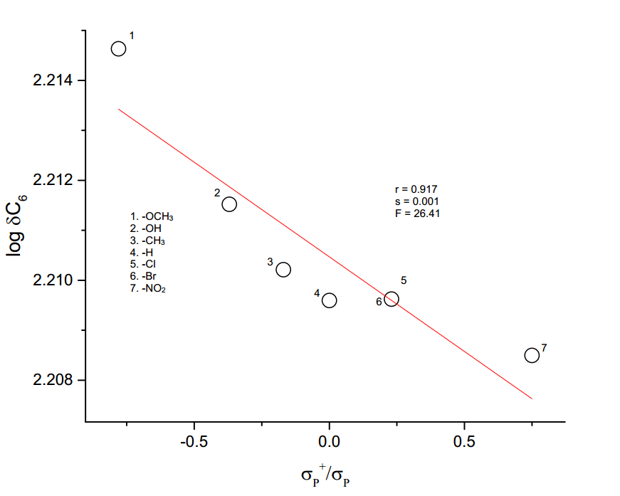

**Figure 3.10** The plot of log δC6 vs *σp+/σp*